PLAYWRIGHT
Playwright Installation Guide
Prerequisites
Before installing Playwright, ensure the Node.js is installed
Playwright runs on Node.js, so Node.js must be installed first.

Installing Node.js (Step-by-Step)
Step 1: Search for Node.js
- Open Google in your browser.
- Type “download Node.js” in the search bar.
- Click the official website:
https://nodejs.org
Always use the official site to avoid malware.
Step 2: Choose the Right Version
On the Node.js download page, you will see two options:
- LTS (Long Term Support)
Recommended for most users
Stable and suitable for production and learning
- Current
Latest features
May be unstable
Select LTS and click Windows Installer (.msi).

Step 3: Run the Installer
- Once downloaded, double-click the .msi file.
- The Node.js Setup Wizard will open.
- Click Next.
- Accept the License Agreement.
- Click Next.

Step 4: Select Installation Options
- Choose the installation folder
Default location is recommended.
- Keep all components checked:
Node.js runtime
npm package manager
Add to PATH

- Click Next → Install.

Step 5: Complete Installation
- Wait for the installation to finish.
- Click Finish when you see:
“Completed the Node.js Setup Wizard”

Verify Node.js Installation
Step 6: Check Node.js Version
Open Command Prompt (cmd)
Run: node -v
Displays the installed Node.js version.

Step 7: Check npm Version
Run: npm -v
Confirms npm (Node Package Manager) is installed successfully.
If both node -v and npm -v show version numbers,
Node.js is installed correctly and you are ready to install Playwright.

Playwright Installation Steps (Windows)
Create a Project Folder
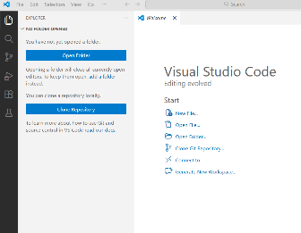
- Create a new folder anywhere on your system
Example: playwright
- Open this folder in VS Code (recommended).
Open Terminal
You can use any of the following:
- Command Prompt
- PowerShell
- VS Code integrated terminal

In VS Code:
Terminal → New Terminal
Run Playwright Setup Command
In the project folder terminal, run: npm init playwright@latest
What this command does:
- Installs Playwright
- Creates a Playwright project structure
- Launches an interactive setup wizard

During setup, you’ll be prompted to choose:
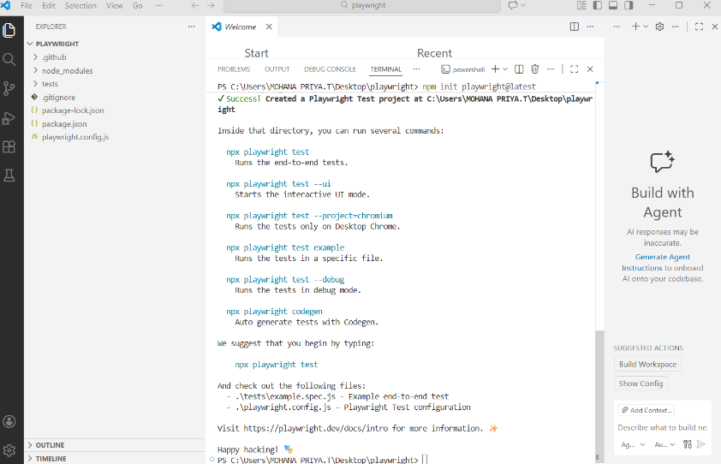
- Language
  - JavaScript
  - TypeScript
press the down arrow to select JavaScript
- Add GitHub Actions for CI?
  - Yes / No
- Install Playwright browsers?
  - Yes / No
Choose Yes (recommended)
Install Browsers (If Skipped)
If you skipped browser installation during setup, run:
npx playwright install
This downloads:
- Chromium
- Firefox
- WebKit

When you get the message with happy hacking

Playwright is installed and ready to use on Windows.

Playwright Introduction
Automation Testing
Testing using code instead of manual actions
Faster, repeatable, reliable
Manual vs Automation
Manual | Automation
Time-consuming | Fast
Human errors | Accurate
Not reusable | Reusable scripts
Playwright
- A modern automation testing tool developed by Microsoft in 2020
- Used for Web UI automation
Application Supported:- Web browser /apps, SPA web application, mobile web apps and API’s.
Language Supported:- Javascript, Typescript, Java, Python and C#.
Browsers supported:- Chromium ,Webkit(Safari) and Firefox(gecko).
OS supported:- Windows, MacOS, Linux ,Support CI Runs
Application Not Supported:- Mobile native apps, Desktop apps (Java / .NET)
Features of Playwright
1. Free and open source
2. Multi Browser and Multi-language
3. Easy setup and configurations
4. Functional, API’s and Accessibility Testing
5. Build-in reporters, Custom reports
6. CI ,CD and Docker
7. Parallel Testing
8. Auto Wait(No need of implicit and explicit Wait
9. Built in Assertions
10. Multi Tab and Multi Window’

Playwright Installation: npm init playwright@latest
Playwright Folder Structure:
project/
├── tests/
├── playwright.config.ts
├── package.json
├── package-lock.json
└── node_modules/

node_modules/
- This folder is automatically created when Playwright is installed
- It contains all external libraries and dependencies required for the project.
- Managed by npm
- Do NOT modify this folder
- Do NOT commit it to Git
tests/
- This is the main folder for Playwright test files.
- All test cases are written here.
- Test files usually end with:
  - .spec.js
  - .spec.ts
Each file represents test scenarios and expected behavior of the application.
.gitignore-file
- Tells Git which files/folders to ignore.
- Prevents unnecessary or sensitive files from being pushed to the repository.
Usually ignores:
- node_modules/
- test-results/
- playwright-report/
- Temporary files
Ensures only important project files are tracked in Git.
package.json
- This is the identity file of the project.
- Contains:
  - Project name & version
  - Dependencies (Playwright)
  - Scripts (commands)
package-lock.json
- Automatically generated by npm.
- Locks the exact versions of installed dependencies.
- Ensures:
  - Same setup
  - Same dependency versions
  - No conflicts across machines
Helps maintain consistency across teams.
playwright.config.js
- This is the configuration file specific to Playwright.
- Controls how tests execute.

Running the Example Test
Create a test file (e.g., example.spec.js):
const { test, expect } = require('@playwright/test');
test('basic test', async ({ page }) => {
await page.goto('https://example.com');
const title = await page.title()
expect(title).toBe('Example Domain');
});
Run the test:
npx playwright test -Runs all test files inside the tests folder.
npx playwright test login.spec.js-Run a Specific Test File
npx playwright test tests/smoke/-Run Tests Inside a Specific Folder
npx playwright test -g "basic test"-Run a Specific Testcase/method by Name
npx playwright test –headed-Run Tests in Headed Mode (Browser Visible)
Headed vs Headless Mode
🔹 Headless (Playwright runs in headless by Default)
- No browser UI
- Faster
- Used in CI/CD
🔹 Headed
- Browser visible
- Good for debugging

Run in Specific Browser
npx playwright test --project=chromium
npx playwright test --trace on
View trace:
npx playwright show-trace trace.zip
npx playwright test --debug -Run in Debug Mode
UI Mode (CUI / UI)
npx playwright test --ui -Run in UI Mode (Visual Test Runner), Opens Playwright UI dashboard

Features:
- Click & run tests
- See logs
- See steps
- Watch execution live
Best for beginners.

Playwright Architecture
Playwright has 3 core components + 2 communication protocols.
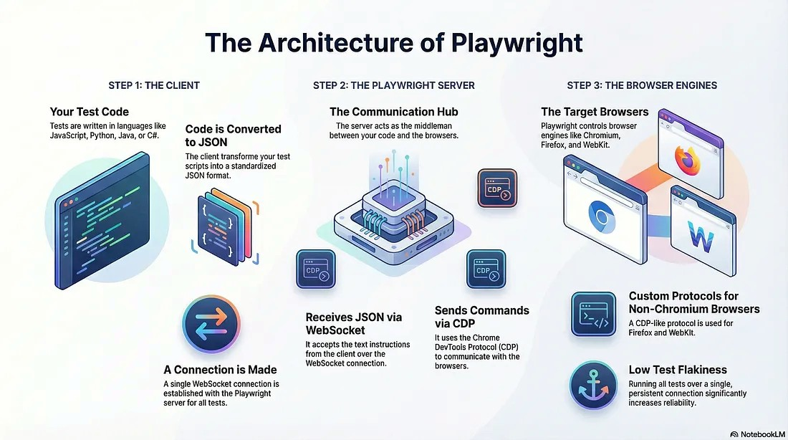
Three Core Components
1. Client Component
Test code
- You write tests using: JavaScript / TypeScript, Python, Java, C#
- This is the interface to control browsers.
2. Playwright Server
It:
- Receives commands from your test code
- Translates and routes them
- Communicates with actual browsers
- Think of it as the command center between your test and the web browser.
3. Browser Engines
These are real browsers where your tests run:
- Chromium / Chrome
- Firefox
- WebKit
- Edge
The browser engines perform actions like clicking, navigation, typing, evaluating scripts, and capturing screenshots.
The Two Protocols That Make It All Work
1. WebSocket Protocol
Used between the Client ↔ Playwright Server
- A single persistent WebSocket connection is created.
- All your test steps travel through this one connection.
- Even if you run 10 tests, they still share the same WebSocket.
Why This Matters
Because this stable connection:
- Reduces network overhead
- Minimizes test flakiness
- Improves execution stability
2. CDP / W1 CDP Protocol
Used between the Server ↔ Browser Engine
CDP (Chrome DevTools Protocol)
Used when interacting with Chrome or Chromium.
W1 Protocol (Playwright’s custom implementation)
Used when working with Firefox and WebKit.
These protocols enable browser-level actions like DOM inspection, navigation, network control, and JavaScript execution.

Step-by-Step Workflow
1️⃣ Your test code is converted to JSON
Playwright converts your test into a structured JSON format.
{
"action": "click",
"selector": "#loginButton"
}
2️⃣ WebSocket connection is established
The client connects to the Playwright server via a single WebSocket.
3️⃣ JSON instructions are sent to the server
Your test steps begin flowing to the Playwright server.
4️⃣ Server communicates with the browser
The server uses:
- CDP for Chrome/Chromium
- W1 protocol for Firefox/WebKit
It sends low-level commands like:
- Click element
- Navigate to URL
- Fill input
- Evaluate script
5️⃣ Browser executes actions and sends responses back
The server receives browser responses and forwards them to your test code.
Why Playwright Is So Stable & Fast
✔️ One WebSocket connection → Less overhead
✔️ Efficient JSON-based messaging
✔️ Direct browser control via CDP/W1
✔️ Parallelism and isolation built-in
✔️ Better flakiness resistance compared to traditional Selenium-based setups
These are some of the reasons why Playwright has become a favorite in modern UI test automation.
Why Playwright is Faster than Selenium
1. No WebDriver
- Selenium → Uses WebDriver (extra communication layer)
- Playwright → Talks directly to browser via DevTools protocol
Less communication overhead = Faster execution
2. Auto Waiting
- Playwright automatically waits for:
  - Element visible
  - Element stable
  - Element enabled
- Selenium needs explicit waits
3. Parallel Execution Built-in
- Playwright has worker-based parallel execution by default.
- Selenium needs Grid setup.
4. Modern Architecture
- Single API for Chromium, Firefox, WebKit.
- Runs faster because of optimized browser handling.

Locator

A locator is used to find elements on a web page so we can perform actions like click, fill, type, submit, etc.

page.locator('selector')

Playwright automatically waits for elements to be visible, attached, and actionable.

1.Locator by Tag Name

Used when the tag is unique or combined with other selectors.
Synatax- page.locator('tagName')

eg:
page.locator('input')
page.locator('button')

--------------------------------------------------------------------------------------------
2. Locator by ID (CSS Selector)-Best Practice

ID should be unique in the DOM.

Synatax- page.locator('#id_value')

page.locator('#email')
--------------------------------------------------------------------------------------------

3.Locator by Class Name .

Synatax- page.locator('.class_value')

Partial class match
page.locator('.inputtext')

If multiple elements share the same class, this will match all of them.
---------------------------------------------------------------------------------------------

5. Locator by Attribute name and value-Very stable and recommended.

Syntax- page.locator("[attributeName="attributeValue"])

page.locator("[placeholder='Email']")
page.locator("[name='email']")
page.locator("[data-testid='royal-email']")
---------------------------------------------------------------------------------------------
6. Combining Multiple Selectors
syntax-page.locator(tagName.classvalue#id_value[attributeName="attributeValue"])

Correct way
page.locator("input[placeholder='Email'].shape")

Wrong way
input [placeholder='Email'] .shape
----------------------------------------------------------------------------------------

7. Using Index When Multiple Elements Match
Page.locator(‘selector’).nth()- index starts from 0
page.locator('.inputtext').nth(0) // first element
page.locator('.inputtext').nth(1) // second element

Shortcut methods:

page.locator('.inputtext').first()
page.locator('.inputtext').last()

Index-based locators are not stable if DOM order changes.
---------------------------------------------------------------------------------------
8. XPath Locators

Playwright supports XPath, but CSS is preferred.

Basic XPath
//tagName[@attributeName="attributeValue"]

page.locator("//input[@name='email']")

XPath with contains()
//tagName[contains(@attributeName,attributePartialValue)]

page.locator("//input[contains(@class,'inputtext')]")

XPath Using Text()

Exact text match
//tagName[text()="full text"]
page.locator("//button[text()='Login']")

Partial text match
page.locator("//tagname[contains(text(),'partial text')]")

page.locator("//button[contains(text(),'Log')]")

using index
(//tagName[@attributeName = "attriValue"][index]
-------------------------------------------------------------------------------------------------------------------
User-Facing Locators

1.Role locator:
finds elements by their role and label.
Syntax
page.getByRole(role, options);

Options you can use:
- name: Text label (string or RegExp)
- exact: Set to true to match full text only
- hidden: Set to true to include hidden elements
eg:
page.getByRole('link', { name: 'Learn More' },{exact=true});
await page.getByRole('checkbox', { name: 'Accept Terms' }).check();
commonly used roles:
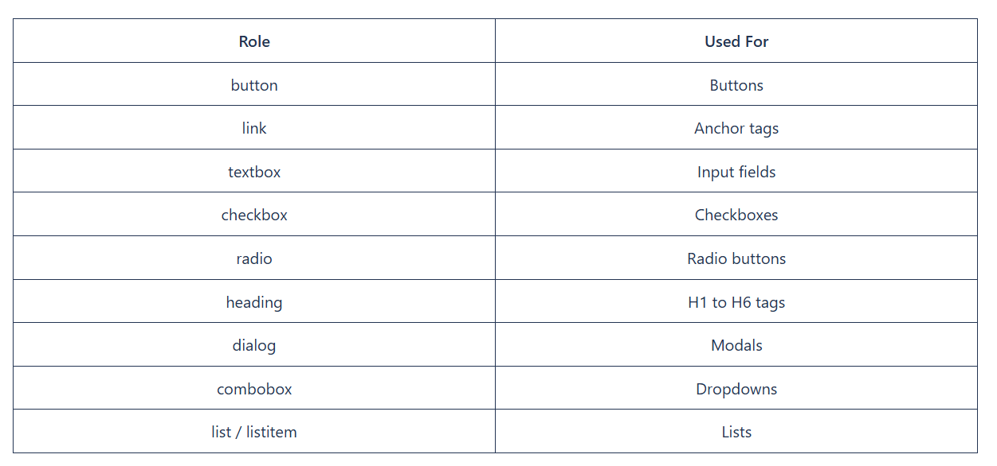

2.Text Locator:
Text locators in Playwright make it easy to find elements based on the visible text on the page.
Syntax:
page.getByText(‘text’);
eg:
await page.getByText('Create new account').click();
or
await page.locator('text=Create new account')
- Case-insensitive matching (e.g., Login and login both work)
- Ignores hidden elements by default
- Returns the first visible match
- Supports RegExp for flexible matching
await page.getByText(/Log/i).click(); // Matches "Login", "Log out", etc.

Features:
- Allows fuzzy or partial matches
- Ideal for testing internationalized content or dynamic strings
- Case-insensitive when /i flag is used
-----------------------------------------------------------------------------------------------------
3.Label Locator:
locates form controls (input, textarea, select) using the text of their associated <label>.
Syntax
page.getByLabel('label tagname text')

How getByLabel() Works Internally
- <label for="id">Text</label>
- <label><input>Text</label>
- aria-label="Text"
- aria-labelledby="id"
eg:
await page.getByLabel('label tagname text').fill('test@gmail.com');
------------------------------------------------------------------------------------------------------------
4.Placeholder Locator:

locates input or textarea elements using the text inside their placeholder attribute — exactly what a user sees inside the field before typing.
Syntax:
page.getByPlaceholder('attribute value of Placeholder attribute')

How getByPlaceholder() Works Internally
Playwright:
- Searches for <input> or <textarea>
- Matches placeholder attribute
- Uses case-insensitive text matching
- Applies strict mode (1 match only)
--------------------------------------------------------------------------------------------------------
5.Text locator
Finds elements by visible text on screen.
Syntax:
page.getByText('visible text')
eg:
await page.getByText('Forgotten password?').click();
How getByText() Works Internally
Playwright:
- Looks at visible text nodes
- Ignores hidden text (display:none)
- Normalizes whitespace
- Case-insensitive by default
- Strict mode enforced

-------------------------------------------------------------------------------------------------
6.AltText Locator
locates elements (mainly images) using their alt attribute.
Syntax:
page.getByAltText('altAttribute value');

When Should You Use getByAltText()?
Images
Logos
Icons rendered as <img>
Accessibility-friendly UIs
When images have meaningful alt text
Note:Only works if alt attribute exists.

How getByAltText() Works Internally
Playwright:
- Searches elements with alt attribute
- Mostly <img> (can be others)
- Case-insensitive matching
- Uses strict mode
Perfect when:
- No visible text
- No role name
- No label
---------------------------------------------------------------------------------------------------------------
7.Title Locator:
locates elements using the title attribute.
Syntax:
page.getByTitle('Title');

How getByTitle() Works Internally
Playwright:
- Looks for elements with title attribute
- Matches visible title text
- Case-insensitive
- Applies strict mode (single match)
-------------------------------------------------------------------------------------------------------------------
Dynamic Locators-Methods for Dynamic Elements

1. contains()

//tag[contains(@attribute,'value')]-use contains() when only part of attribute is stable.

//input[contains(@id,"user_")]

example:
<input id="user_982341">

After Refresh
<input id="user_548739">
<input id="1455User">
<input id="1255User">
That is a dynamic id.

2.starts-with()/ends-with()

//tag[starts-with(@attribute,'value')]-use When attribute starts same but ends differently.

3. text()

//tag[text()='Exact Text']
//button[contains(text(),'Sub')]
//span[normalize-space(text())="Update location"]

4. Using AND / OR

//tag[@attr1='value1' and @attr2='value2']-Makes locator more stable.

5. position()

(//input[@type='text'])[2]
Used when no unique attribute exists.
Avoid position unless absolutely necessary.

6. XPath Axes

Syntax of Axes
//currentNode/axis::targetNode

Types XPath Axes

parent
child
following =>younger
preceding => yelder
ancestor =>grand-parent
descendant =>grand-child

parent Axis
Used to move from child → parent

Syntax:
//childElement/parent::parentTag
----------------------------------------------------------------------------------------------------------
child Axis
Used to move from parent → direct child
Syntax:
//parentTag/child::childTag
Note:Only direct children, not grandchildren.
----------------------------------------------------------------------------------------------------------
following Axis
Selects everything after current node in DOM

Syntax:
//node/following::targetTag
//label[text()='Username']/following::input[1]
----------------------------------------------------------------------------------------------------------
preceding Axis
Selects all nodes before current node

Syntax:
//node/preceding::tag
following-sibling Axis
Selects next sibling elements

Syntax:
//node/following-sibling::tag
//td[text()='John']/following-sibling::td[1]
--------------------------------------------------------------------------------------------------------------------
preceding-sibling Axis
📌 Select previous sibling
Example:

Select checkbox before "Smartphone"

//td[text()='Smartphone']/preceding-sibling::td/input
-------------------------------------------------------------------------------------------------------------------
ancestor Axis
Move upward through all parent levels

Syntax:
//node/ancestor::tag
Example:
//input[@name='username']/ancestor::form
------------------------------------------------------------------------------------------------------------------
descendant Axis
Select all children & grandchildren

Syntax:
//parent/descendant::child
Example:
//form/descendant::input //Selects all input fields inside form.

Difference Between Axes (Very Important for Interview)
Axis Direction Scope
parent Up One level
ancestor Up All levels
preceding Up Everything before
preceding-sibling same level before sibling only
child Down Direct only
descendant Down All levels
following Down in DOM Everything after
following-sibling Same level Next siblings only

Playwright Page & Locator Methods
Playwright methods
Navigation Methods
page.goto(url)
Navigates to a URL.
await page.goto("https://example.com");
Used to open application
Waits for page load automatically
page.reload()
Refreshes the page.
await page.reload();
Used for testing refresh behavior
Example: Check if data resets after refresh
page.goBack()
await page.goBack();
Browser back button testing
page.goForward()
await page.goForward();
Browser forward button testing
page.url()
Returns current URL
console.log(page.url());
Used for URL validation
Locator Creation
page.locator(selector)
Creates a smart element reference.
const loginBtn = page.locator("#login");
✔ Auto waits
✔ Retry mechanism
Action Methods
locator.click()
await locator.click();
✔ Waits for element
✔ Scrolls automatically
✔ Waits for stability

locator.fill(value)
await locator.fill("INDIA");
Clears existing value and Fast
locator.type(value)
await locator.type("India");
Types character by character
Useful for auto-suggestion testing
locator.press()
await locator.press("Enter");
Keyboard actions
locator.check() / locator.uncheck()
await checkbox.check();
Checkbox handling
Only works for input[type=checkbox]
locator.selectOption()
await dropdown.selectOption("india");
Used for <select> dropdown
Can pass value, label, index
Text & Value Methods
locator.innerText()
Returns only visible text
const text = await locator.innerText();
Best for assertions
Ignores hidden elements
locator.textContent()
Returns text including hidden
await locator.textContent();
Includes hidden text
locator.inputValue()
await locator.inputValue();
Gets value of input field
locator.getAttribute(name)
await locator.getAttribute("href");
Gets attribute value
State Checking Methods
locator.isVisible()
await locator.isVisible();
locator.isEnabled()
await locator.isEnabled();
locator.isChecked()
await locator.isChecked();
Used in conditional logic

Screenshot Methods

page.screenshot()
await page.screenshot({ path: "page.png" });

locator.screenshot()
await locator.screenshot({ path: "button.png" });
Used in failure debugging
Used in visual testing

Wait Methods
waitForTimeout()
await page.waitForTimeout(5000);
Avoid in real automation
Only for debugging
Why avoid
- Makes test slow
- Not dynamic
- Bad practice in interviews

Better Wait Alternatives
locator.waitFor()
await locator.waitFor({ state: "visible" });

page.waitForURL()
await page.waitForURL("**/dashboard");

page.waitForLoadState()
await page.waitForLoadState("networkidle");

Advanced Useful Methods
locator.count()
await locator.count();
✔ Used in tables & lists
locator.nth(index)
locator.nth(2).click();
locator.first() / locator.last()
Select specific element
page.on("dialog")
Alert handling
page.hover()
await locator.hover();
Mouse hover dropdown
page.dragAndDrop()
await page.dragAndDrop("#source", "#target");
page.setViewportSize()
await page.setViewportSize({ width: 1280, height: 720 });

Assertion
Playwright includes test assertions in the form of expect function. To make an assertion, call expect(value)
By default, the timeout for assertions is set to 5 seconds. Learn more about various timeouts.
Auto-retrying assertions
The following assertions will retry until the assertion passes, or the assertion timeout is reached. Note that retrying assertions are async, so you must await them.
Assertion Description
---------------------------- ----------------------------------
await expect(locator).toBeAttached() Element is attached
await expect(locator).toBeChecked() Checkbox is checked
await expect(locator).toBeDisabled() Element is disabled
await expect(locator).toBeEditable() Element is editable
await expect(locator).toBeEnabled() Element is enabled
await expect(locator).toBeHidden() Element is not visible
await expect(locator).toBeVisible() Element is visible
await expect(locator).toContainText() Element contains text
await expect(locator).toContainClass() Element has specified CSS classes
await expect(locator).toHaveAttribute() Element has a DOM attribute
await expect(locator).toHaveClass() Element has specified CSS class property
await expect(locator).toHaveCount() List has exact number of children
await expect(locator).toHaveCSS() Element has CSS property
await expect(locator).toHaveId() Element has an ID
await expect(locator).toHaveRole() Element has a specific ARIA role
await expect(locator).toHaveText() Element matches text
await expect(locator).toHaveValue() Input has a value
await expect(locator).toHaveValues() Select has options selected
await expect(page).toHaveTitle() Page has a title
await expect(page).toHaveURL() Page has a URL
await expect(response).toBeOK() Response has an OK status
----------------------------------------------------------------------------------------------------------------------------
Non-retrying assertions
These assertions allow to test any conditions, but do not auto-retry. Most of the time, web pages show information asynchronously, and using non-retrying assertions can lead to a flaky test.

Prefer auto-retrying assertions whenever possible. For more complex assertions that need to be retried, use expect.poll or expect.toPass.
Assertion Description
expect(value).toBe() Value is the same
expect(value).toBeDefined() Value is not undefined
expect(value).toBeFalsy() Value is falsy, e.g. false, 0, null, etc.
expect(value).toBeGreaterThan() Number is more than
expect(value).toBeGreaterThanOrEqual() Number is more than or equal
expect(value).toBeInstanceOf() Object is an instance of a class
expect(value).toBeLessThan() Number is less than
expect(value).toBeLessThanOrEqual() Number is less than or equal
expect(value).toBeNaN() Value is NaN
expect(value).toBeNull() Value is null
expect(value).toBeTruthy() Value is truthy, i.e. not false, 0, null, etc.
expect(value).toBeUndefined() Value is undefined
expect(value).toContain() String contains a substring
expect(value).toContain() Array or set contains an element
expect(value).toContainEqual() Array or set contains a similar element
expect(value).toEqual() Value is similar - deep equality and pattern matching
expect(value).toHaveLength() Array or string has length
expect(value).toHaveProperty() Object has a property
expect(value).toMatch() String matches a regular expression
expect(value).toMatchObject() Object contains specified properties
expect(value).toStrictEqual() Value is similar, including property types
expect(value).toThrow() Function throws an error
Asymmetric matchers
These expressions can be nested in other assertions to allow more relaxed matching against a given condition.
Matcher Description
expect.any() Matches any instance of a class/primitive
expect.anything() Matches anything
expect.arrayContaining() Array contains specific elements
expect.arrayOf() Array contains elements of specific type
expect.closeTo() Number is approximately equal
expect.objectContaining() Object contains specific properties
expect.stringContaining() String contains a substring
expect.stringMatching() String matches a regular expression

Alert
Alerts are browser-native popups created by JavaScript.They are NOT part of the DOM, so you cannot inspect them using DevTools.
They block the page until handled.
Simple Alert
alert("Login successful");
- Has OK button only
- No input
Confirm Alert
confirm("Are you sure?");
- OK → true
- Cancel → false
Prompt Alert
prompt("Enter your name");
- Accepts text input
- OK → returns text
- Cancel → returns null
Playwright Alert Handling
Listen to dialog event
page.on() is used to listen to browser events and execute code when those events occur.
It does not perform actions
It does not assert UI directly
It reacts to browser-level events
page.on(eventName, callback)
eventName → what you are listening for
callback → code that runs when event happens
dialog invokes call back – Alerts, Confirm, Prompt
dialog.type()-alert/prompt/confirm
dialog.accept()-Ok+test
dialog.dismiss()-cancel
Modern Alert
can inspect them using DevTools.
Perform normal actions on them

CODE FOR ALERT
import { test, expect } from "@playwright/test";

test("Handle Native and Modern Alert", async ({ page }) => {
await page.goto("https://letcode.in/alert");
// Native Alert Handling
page.on("dialog", async (dialog) => {
expect(dialog.type()).toBe("alert"); // assertion
expect(dialog.message()).toContain("Hey"); // adjust based on actual text
await dialog.accept();
});
await page.getByRole("button", { name: "Simple Alert" }).click();

// Modern Alert Handling
await page.getByRole("button", { name: "Modern Alert" }).click();
const modernAlertText = page.getByText(
"Modern Alert - Some people address me as sweet alert as well"
);
// Assertion instead of console.log
await expect(modernAlertText).toBeVisible();
await expect(modernAlertText).toHaveText(
"Modern Alert - Some people address me as sweet alert as well"
);
// Close modern alert
await page.getByLabel("close").click();

});

Frames[iframe]
An iframe is a webpage inside another webpage.
Your main page = Parent page
Inside it = iframe (child DOM)
Playwright CANNOT access iframe elements directly from the main page.
If an element is inside <iframe> tag in DOM, it is NOT accessible using page.locator().

Frame using frameLocator()
page.frameLocator('#Id').locator('#id').fill();
If Nested Iframe
page.frameLocator('Outerframe locator').page.frameLocator('Inner Frame Locator').locator(".element").fill();
How to identify iframe (Quick)
Inspect element → if <iframe> appears above it in DOM
DevTools breadcrumb shows iframe > html > body

Frame by Index
When to use:
iframe has no id / name
order is fixed
We can access frame using index position
Index starts from 0
[0] Main page
[1] 1st iframe
[2] 2nd iframe
page.frames()[index];
page.frames()[1];//1st iframe
page.frames()[2];//2nd iframe

frameLocator vs frame by index
--------------------------------
Method Recommended
frameLocator() YES
page.frames()[index] Only if needed

frameLocator() | frames[index]
Stable | Not stable
Readable | Hard to maintain
No index confusion | Index may change
Recommended byPlaywright | Old style
CODE FOR FRAMES
Frames without index - Best Practice
import { test, expect } from "@playwright/test";
test("Frames without index", async ({ page }) => {
await page.goto("https://letcode.in/frame");
// Switch to first frame
const firstFrame = page.frameLocator("#firstFr");
await firstFrame.locator('[placeholder="Enter name"]').fill("Trend");
await firstFrame.locator('[name="lname"]').fill("nologies");
// Switch to inner frame inside first frame
const innerFrame = firstFrame.frameLocator('iframe[src="innerframe"]');
await innerFrame.locator('[name="email"]').fill("Trendno@gmail.com");
// Assertion
await expect(
innerFrame.locator('[name="email"]')
).toHaveValue("Trendno@gmail.com");
});
Using Frame Index (Not Recommended but Corrected)
import { test, expect } from "@playwright/test";
test("Frames using index", async ({ page }) => {
await page.goto("https://letcode.in/frame");
const frames = page.frames();
// Print frame details
frames.forEach((frame, index) => {
console.log(`Index: ${index} URL: ${frame.url()}`);
});
// Usually:
// frames[1] -> firstFr
// frames[2] -> innerframe (depends on DOM)
await frames[1].locator('[placeholder="Enter name"]').fill("Trendo");
await frames[1].locator('[name="lname"]').fill("nologies");
await frames[2].locator('[name="email"]').fill("Trendno@gmail.com");
// Assertion
await expect(
frames[2].locator('[name="email"]')
).toHaveValue("trendno@gmail.com");
});

Dropdowns
A dropdown lets users select one (or multiple) options from a list.
In HTML, dropdowns are mainly of 2 types:
Native <select> dropdown
Custom / non-select dropdown (div, ul/li, React, Angular, etc.)
1.Native <select> dropdown
Single Select
Basic syntax
await page.selectOption(selector, option); or await page.locator(#id).selectOption(value or label or id);
Select by value
await page.selectOption(locator, "value");
Select by label (visible text)
await page.selectOption('#day', { label: '2' });
Select by index
await page.selectOption('#day', { index: 1 });

Multiple Selection Dropdown
await page.selectOption(selector, [option1,option2......]);
await page.selectOption('#skills', ['js', 'ts']);

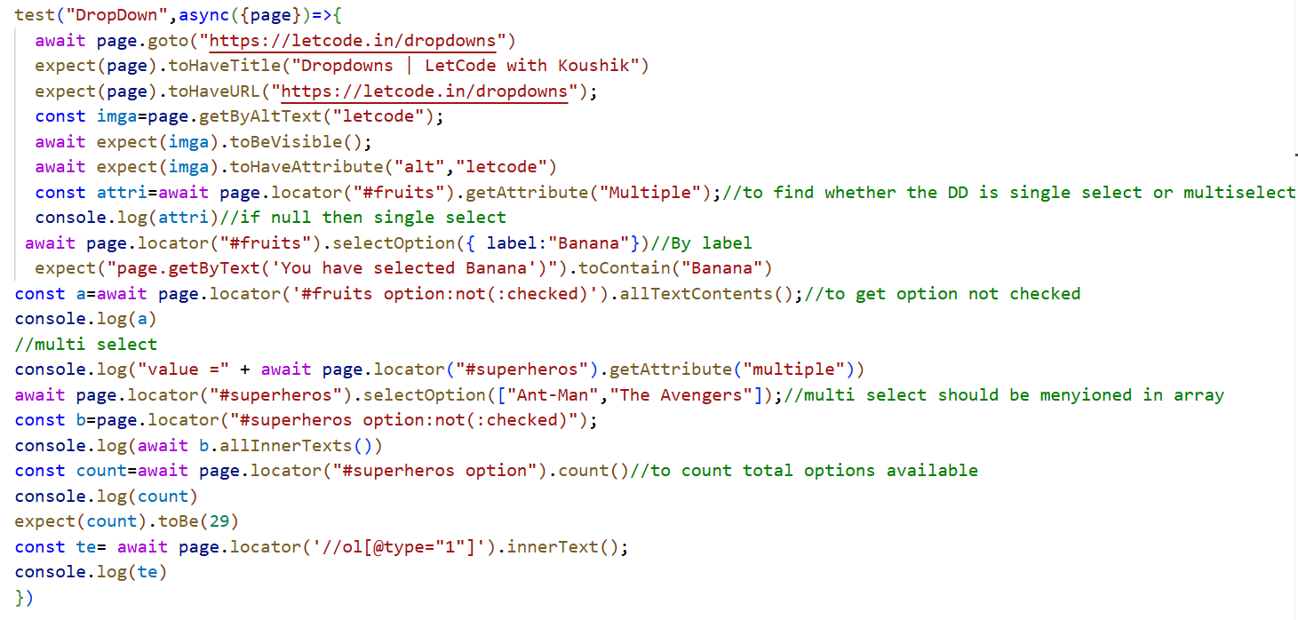

Non-select dropdown
// Open dropdown
await page.locator('#country').click();
// Select option
await page.locator('text=India').click();
This works for 90% of modern dropdowns

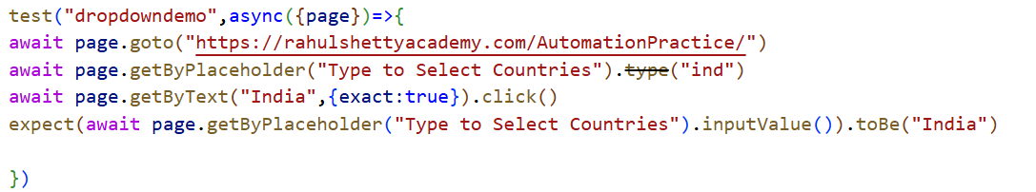

Dropdown with Search Box
Click dropdown
Type text
Press Enter
await page.locator('.dropdown').click();
await page.keyboard.type('India');
await page.keyboard.press('Enter');
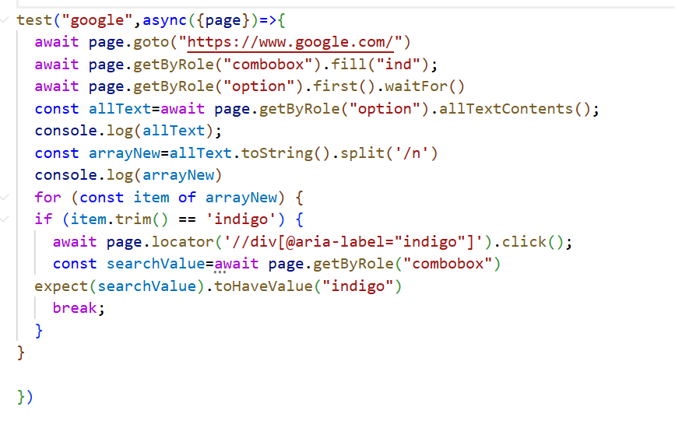

Dropdown Inside iframe
const frame = page.frameLocator('iframe');
await frame.locator('#country').click();
await frame.locator('text=India').click();

WINDOW HANDLING IN PLAYWRIGHT
Window handling means:
Managing multiple browser tabs or windows opened during automation.
Examples:
- Amazon product opens in new tab
- Login with Google
- Payment gateway (Razorpay/Stripe)
- Clicking external links
Important Terminology in Playwright
Browser Concept | Playwright Term
Browser | browser
Incognito Session | context
Tab / Window | page
Parent Window | Original page
Child Window | Popup page
Key Difference: Selenium vs Playwright
Selenium | Playwright
getWindowHandles() | ❌ Not needed
switchTo().window() | ❌ Not needed
Manual switching | Automatic page control
Window ID based | Event based
Important Concept:
Playwright does NOT switch windows.
It listens for new windows.
When you click a link that opens a new tab:
Playwright emits an event called: 'popup'
Golden Pattern for Window Handling
const [newPage] = await Promise.all([
page.waitForEvent('popup'),
locator.click()
]);

Why Promise.all?
- Click and popup happen at same time
- Prevents race condition
- Avoids timeout errors
CODE FOR WINDOW HANDLING
//SINGLE POPUP
import { expect, test } from "@playwright/test";
test("google", async ({ page }) => {
await page.goto(
"https://www.hyrtutorials.com/p/window-handles-practice.html",
);
const [eventNewWindow] = await Promise.all([
page.waitForEvent("popup"),
await page.locator("#newWindowBtn").click(),
]);
await eventNewWindow.waitForLoadState();
await eventNewWindow.setViewportSize({ width: 1920, height: 1080 });
console.log(await eventNewWindow.title());
await page.bringToFront();
await page.waitForTimeout(3000);
console.log(await page.title());
await eventNewWindow.bringToFront();
await eventNewWindow.waitForTimeout(3000);
});
// MULTITAB PAGE
test("multitab", async ({ page, context }) => {
await page.goto(
"https://www.hyrtutorials.com/p/window-handles-practice.html",
);
await page.click("#newTabsBtn");
await page.waitForTimeout(3000);
const allpages = context.pages();
for (let i = 1; i < allpages.length; i++) {
const tab = allpages[i];
await tab.waitForLoadState();
console.log(await tab.title());
}
console.log(await page.title());
});
//AMAZON PRODUCT CLICK
test("amazon", async ({ page, context }) => {
await page.goto("https://www.amazon.in/");
await page.locator("#twotabsearchtextbox").fill("iphone");
await page.keyboard.press("Enter");
await page.waitForSelector("a.a-link-normal h2");
const text = await page.locator("a.a-link-normal h2").allTextContents();
console.log(text);
for (let i = 0; i < 3; i++) {
const [newpage] = await Promise.all([
page.waitForEvent("popup"),
page.locator("a.a-link-normal h2").nth(i).click(),
]);
await newpage.waitForLoadState();
console.log(await newpage.title());
}
});

WEBTABLE
A web table is an HTML table used to display data in rows and columns.
Basic structure:
<table>
<thead>
<tr>
<th>Name</th>
<th>Role</th>
</tr>
</thead>
<tbody>
<tr>
<td>John</td>
<td>QA</td>
</tr>
</tbody>
</table>
<table> – The Container
<table> is the main element that holds all table data.
tr = Table Row, It represents a normal cell inside a row.
td = Table Data, one column value.
th = Table Header
Difference:
- th → header cell
- td → normal data cell
Types of WebTables
1. Static WebTable
- Data does NOT change dynamically
- Row & column positions remain fixed
- Example: book price table
2. Dynamic WebTable
- Row order changes
- Column position may change
- Data updates frequently
- Example: Task Manager table (CPU, Memory)
3. Pagination WebTable
- Data split across multiple pages
- Requires clicking Next/Previous
CODE FOR WEBTABLE

import { test } from "@playwright/test";
//STATIC WEBTABLE
test("static webtable", async ({ page }) => {
await page.goto("https://testautomationpractice.blogspot.com/");
const row = await page.locator("table[name='BookTable'] tbody tr");
const rowCount = await row.count();
console.log(rowCount);
const column = page.locator('table[name="BookTable"] tbody tr th');
const columnCount = await column.count();
console.log(columnCount);
//Single cell value retrive
const rowSelected = await row.nth(1);
const cellValue = await rowSelected.locator("td").nth(0);
const Value = await cellValue.innerText();
console.log(Value);

const rowSelectedHeader = await row.nth(0);
const cellValue1 = await rowSelected.locator("td").nth(2);
const Value1 = await cellValue1.innerText();
console.log(Value1);

//whole row
const rowcontent = await row.locator("td").allTextContents();
console.log(rowcontent);
});

//DYNAMIC WEBTABLE

test("Dynamic", async ({ page }) => {
await page.goto("https://testautomationpractice.blogspot.com/");
const row = page.locator("table#taskTable tbody tr");
const col = page.locator("table#taskTable thead tr th", {
hasText: "Memory",
});
const colIndex = (await col.innerText()).indexOf();
const target = row.locator(":scope", { hasText: "Firefox" });
const valuereti = await target.locator("td").nth(colIndex).innerText();

console.log(valuereti);
if (valuereti.trim().toLowerCase().includes("mbps")) {
console.log("Got Mbps value");
} else if (valuereti.trim().toLowerCase().includes("mb")) {
console.log("Got MB value");
}
});

// PAGINATION WEBTABLE

test("pagination", async ({ page }) => {
await page.goto("https://testautomationpractice.blogspot.com/");
const product = ["Smartwatch", "Tablet", "Wireless Earbuds"];
for (const item of product) {
const row = await page.locator("table#productTable tbody tr"); //row
const selectedrow = row.locator(":scope", { hasText: item });
await selectedrow.locator('td input[type="checkbox"]').check();
await page.waitForTimeout(5000);
}
});

test("pagination with multi page", async ({ page }) => {
await page.goto("https://testautomationpractice.blogspot.com/");
const products = [
"Smartwatch",
"Tablet",
"Wireless Earbuds",
"Portable Charger",
"Soundbar",
];
const row1 = await page.locator("table#productTable tbody tr");
const pageNo = await page.locator("#pagination li a");

for (const item of products) {
let found = false;
for (let i = 0; i < (await pageNo.count()); i++) {
await pageNo.nth(i).click();
await page.waitForSelector("table#productTable tbody tr");
const rowTargetted = await row1.locator(":scope", { hasText: item });
if ((await rowTargetted.count()) > 0) {
await rowTargetted.locator('td input[type="checkbox"]').check();
found = true;
break;
}
}
if (!found) {
console.log("not found");
}
}
});

SDOM-Shadow DOM
Shadow DOM is a browser feature that allows developers to create a hidden DOM tree inside an element.
It is mainly used in:
- Web Components
- Modern UI frameworks
- Reusable custom components
The internal DOM is encapsulated (isolated).
Shadow DOM types:
- Open → Automatable
Playwright automatically pierces shadow DOM easily
Selenium cannot directly locate inside shadow DOM.
- Closed → Not automatable (both tools fail)

Annotations
Annotations control test execution behavior.
test.skip();
Skips test completely.
test.skip('Login test', async ({ page }) => {
// will not execute
});
Use Case:
- Feature not ready
- Bug exists
test.only();
Runs only that test.
test.only('Login test', async ({ page }) => {
});
Used during debugging
Never commit to Git
test.fixme();
Marks test as known failure.
test.fixme('Payment test', async ({ page }) => {
});
Used when:
- Feature under development
- Known issue
test.slow()
- Marks test as slow (triples timeout).
Hooks
Hooks are setup and teardown methods.
Types of Hooks
Hook | Runs When
beforeAll | Once before all tests
afterAll | Once after all tests
beforeEach | Before every test
afterEach | After every test

beforeEach()
test.beforeEach(async ({ page }) => {
await page.goto('https://example.com');
});
Runs before every test.
afterEach()
test.afterEach(async ({ page }) => {});
test.afterEach(async ({ page }) => {
await page.close();
});
Cleanup activity.
beforeAll()
test.beforeAll(async () => {
console.log('Starting test suite');
});
Runs once.
afterAll()
test.afterAll(async () => {
console.log('Suite completed');
});
Hook Execution Flow
If you have 2 tests:
Execution order:
beforeAll
beforeEach
Test 1
afterEach
beforeEach
Test 2
afterEach
afterAll

Page Object Model (POM)
POM is a design pattern where each page of the application is represented as a separate class file.
Instead of writing locators and actions inside test files, we move them to a separate Page class.
Problem Without POM
- Repeated locators
- Hard to maintain
- If locator changes → update in all files
- Test files become messy
Benefits of POM
✔ Reusable code
✔ Easy maintenance
✔ Clean test files
✔ Better readability
✔ Scalable framework
✔ Real-time project structure

Folder Structure (Best Practice)
project/
├── tests/
│ └── login.spec.js
├── pages/
│ └── loginPage.js
├── utils/
├── playwright.config.ts

Step-by-Step POM Implementation
Step 1: Create Page Class
📁 pages/loginPage.js
export class LoginPage {
constructor(page) {
this.page = page;
// Locators
this.username = page.locator('#username');
this.password = page.locator('#password');
this.loginBtn = page.locator('#login');
}
async goto() {
await this.page.goto('https://example.com/login');
}
async login(user, pass) {
await this.username.fill(user);
await this.password.fill(pass);
await this.loginBtn.click();
}
}

Step 2: Use in Test File
📁 tests/login.spec.js
import { test, expect } from '@playwright/test';
import { LoginPage } from '../pages/loginPage';
test('Valid Login', async ({ page }) => {
const login = new LoginPage(page);
await login.goto();
await login.login('admin', 'admin123');
await expect(page).toHaveURL(/dashboard/);
});

How POM Works Internally
Test File → Calls → Page Class → Uses Locators → Performs Actions
Test file = What to test
Page file = How to interact
Data-Driven Testing (JSON)
Data-Driven Testing means executing the same test with multiple sets of data.
Instead of writing 5 login tests manually, we use one test and pass different data.
Data-Driven Using JSON
Step 1: Create JSON file
📁 data/loginData.json
[
{
"username": "admin",
"password": "admin123"
},
{
"username": "user1",
"password": "user123"
},
{
"username": "wrong",
"password": "wrong123"
}
]
Step 2: Use in Test File
import { test, expect } from '@playwright/test';
import loginData from '../data/loginData.json';
for (const data of loginData) {
test(`Login Test for ${data.username}`, async ({ page }) => {
await page.goto('https://example.com/login');
await page.fill('#username', data.username);
await page.fill('#password', data.password);
await page.click('#login');
});
}
Playwright creates 3 separate tests automatically.
Output:
✓ Login Test for admin
✓ Login Test for user1
✓ Login Test for wrong

Cucumber Framework
Cucumber is a BDD (Behavior Driven Development) testing framework.
It allows us to write test cases in simple English language instead of programming language.
It uses something called Gherkin syntax.
Def: Cucumber is a tool that allows us to write automation test cases in plain English and connect them to code.
The name comes from the Ruby community originally.It later expanded to Java, JavaScript, .NET etc.
Official package we use in JS: Cucumber
In JavaScript we install by using this command in terminal: npm install @cucumber/cucumber
Instead of writing:
test('login test', async () => { ... })
We write:
Feature: Login
Scenario: Valid login
Given user is on login page
When user enters valid credentials
Then user should see dashboard
This is called Gherkin language
Why Do We Use Cucumber
Business Readable
Non-technical people can read:
- Business Analysts
- Product Owners
- Clients
Improves Communication
Separation of Logic
Cucumber separates:
- Feature file → What to test
- Step definition → How to test

Playwright + Cucumber Architecture
Real-Time Framework Folder Structure
playwright-bdd-framework/
│
├── features/
│ ├── login.feature
│ ├── search.feature
│
├── step-definitions/
│ ├── login.steps.js
│ ├── search.steps.js
│
├── pages/
│ ├── LoginPage.js
│ ├── SearchPage.js
│
├── hooks/
│ ├── hooks.js
│
├── utils/
│ ├── config.js
│ ├── testData.json
│
├── reports/
│
├── allure-results/
│
├── cucumber.js
├── package.json
├── Jenkinsfile
└── README.md

Framework Flow
Feature File (Gherkin)
↓
Step Definitions (JS)
↓
Playwright API
↓
Browser

Playwright + Cucumber-Working
Step 1: Feature File (Business Layer)
📁 login.feature
Feature: Login Feature
Scenario: Valid Login
Given user is on login page
When user enters valid credentials
Then user should see dashboard
This is plain English.

🔹 Step 2: Step Definition (Technical Layer)
📁 login.steps.js
const { Given, When, Then } = require('@cucumber/cucumber');
const { chromium } = require('playwright');
let browser, page;
Given('user is on login page', async function () {
browser = await chromium.launch();
const context = await browser.newContext();
page = await context.newPage();
await page.goto('https://example.com');
});

Now Cucumber connects:
Given user is on login page
with:
Given('user is on login page', function() { ... })
Matching is based on text.

Internally What Happens?
When you run:
npx cucumber-js
Cucumber:
Reads feature file
Reads step definitions
Matches step text
Executes matching function
Sends results to reporter

Why Combine Playwright + Cucumber?
🔹 Playwright
Playwright Used for browser automation.
🔹 Cucumber
Used for writing readable test scenarios.
Together :Readable + Powerful Automation

Comparison: Without vs With Cucumber
Without Cucumber (Only Playwright) | With Cucumber
test('login test', async ({ page }) => {  await page.goto(...)  }); | Feature:  Scenario: Valid Login  Given user is on login page  When user enters credentials  Then user should see dashboard
Only technical people understand. | Everyone understands.

cucumber.js File
This file is a Cucumber configuration file.
When npx cucumber-js command is run ,Cucumber automatically looks for cucumber.js file in the root folder.
This file tells Cucumber:
- Where step definitions are
- Where hooks are
- Which reporters to use
- How many parallel threads to run
- Other runtime options
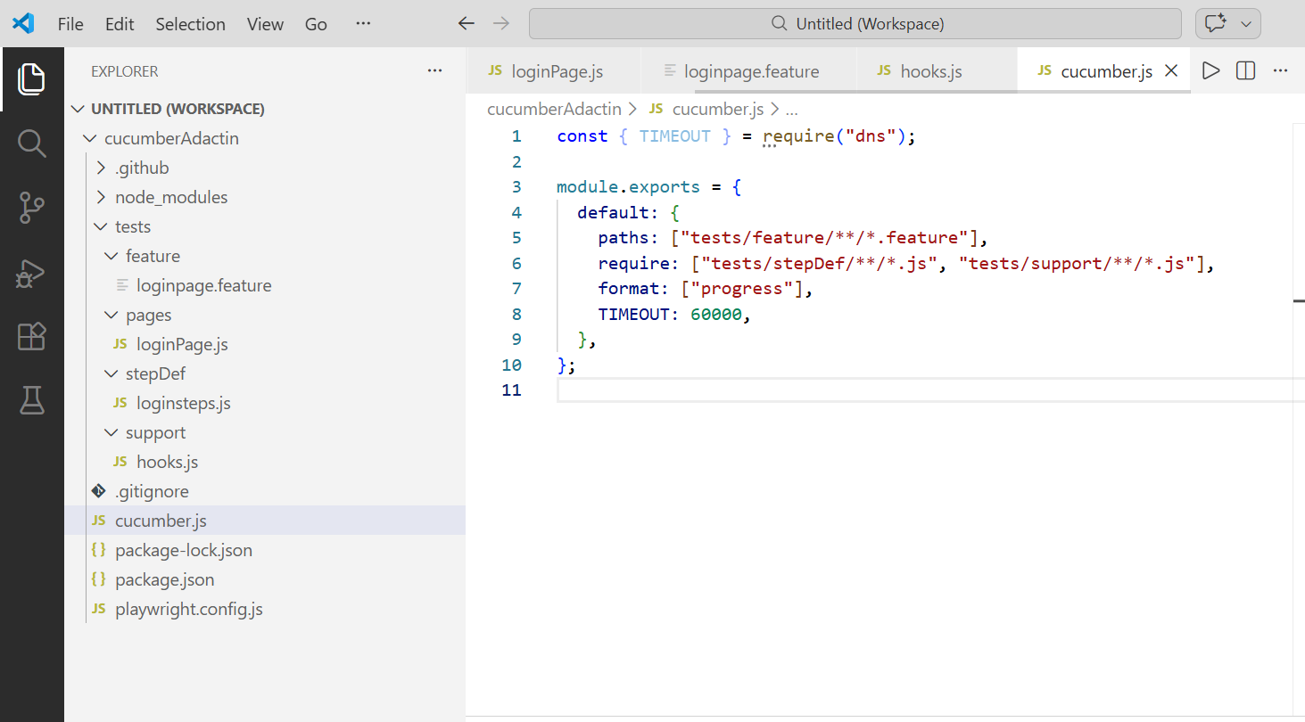

In a Cucumber (Node.js) framework, the reason you usually use module.exports instead of directly using export class is because of the module system used by Node.js.
There are two module systems in JavaScript:
Module System | Syntax | Used In
CommonJS | require() / module.exports | Default in Node.js, Cucumber
ES Modules (ESM) | import / export | Modern JS, TypeScript
Cucumber by default runs in CommonJS mode, so it expects:
const LoginPage = require('../pages/LoginPage');
For this to work, the class must be exported using:
module.exports = LoginPage;

Example (CommonJS – Works in Cucumber)
LoginPage.js
class LoginPage {
login(username, password) {
console.log("Logging in...");
}
}
module.exports = LoginPage;
Step Definition
const LoginPage = require('../pages/LoginPage');
const loginPage = new LoginPage();
loginPage.login("admin", "123");

Why export class does NOT work directly
If you write:
export class LoginPage {}
Node expects the file to be treated as an ES Module.
But most Cucumber projects run with CommonJS, so Node throws an error like:
SyntaxError: Unexpected token 'export'
or
Cannot use import statement outside a module

When export CAN be used
If your project uses ES Modules or TypeScript, then you can write:
export class LoginPage {}
and import using:
import { LoginPage } from '../pages/LoginPage';
But for this you must configure:
package.json
{
"type": "module"
}
or use TypeScript compiler.

Simple Way to Remember (Interview Answer)
You can say:
Cucumber frameworks in Node.js typically use the CommonJS module system. Because of that, classes are exported using module.exports and imported using require(). The export syntax belongs to ES Modules and requires additional configuration like setting "type": "module" in package.json.

✅ Quick Comparison
CommonJS | ES Modules
module.exports = LoginPage | export class LoginPage
require() | import
Default in Node + Cucumber | Modern JS / TypeScript

